Directions: Sketch the graphs of the following functions.

$f(x)=(x−1)^{3}+4$ $f(x)=−\sqrt{x+2}+1$ $f(x)=|x+3|$ $f(x)=3(x+2)^{2}−1$ $f(x)=\frac{1}{x−2}+5$

Vertex @ ( 1, 4 ) Vertex @ ( -2, 1 ) Vertex @ ( -3, 0 ) Vertex @ ( -2, -1 ) Vertex @ ( 2, 5 )

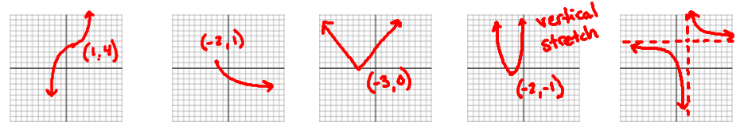

Directions: Convert the degree measure to radians or vice-versa.

$θ=\text{210}°$ $θ=\text{420}°$ $θ=−\frac{9π}{4}$ $θ=\frac{7π}{6}$

$\frac{7π}{6}$ $\frac{7π}{3}$ $−\text{405}°$ $\text{210}°$

Directions: Identify the Quadrant and Reference Angle and evaluate the functions.
$\text{sin}(\text{150}°)=\frac{1}{2}$ $\text{tan}\left(\frac{4π}{3}\right)=\sqrt{3}$ $\text{cos}(\text{135}°)=−\frac{\sqrt{2}}{2}$ $\text{csc}\left(−\frac{7π}{6}\right)=2$ $\text{cot}\left(\frac{5π}{2}\right)=∅$ $\text{sec}\left(−\frac{3π}{4}\right)=−\sqrt{2}$

